**Unit 11 Sad movies make me cry.**

**Section B3 (3a-Self check)**

**【学习目标】**

1．掌握本课时和情感相关的重点词汇、短语以及句型“make＋宾语＋宾语补足语”用法。

2．能够讲述一些令你感到快乐或者悲伤的经历。

3．对待生活中发生的对自己产生消极情绪的事情，保持积极乐观的心态。

4. 熟练运用本单元句型进行会话和写作。

**【重点和难点】**

【学习重点】

掌握和情感相关的词汇短语，能够运用它们交流个人情感。

学习make sb. ＋*adj*.和make sb. do sth.，并补充be made to do sth. 的句型用法。

【学习难点】

能够对话交流过去发生的事情对自身和他人产生的情感影响。

掌握P86重点单词和短语；进一步掌握学习make的用法。

**【课前预习】**

一、英汉互译。

1. the more …the more _____________

2. 使我困倦 _____________

3. waiting for her _____________

4. 友谊 _____________

5. to start with _____________

6. 让……失望 _____________

7. kick sb. off _____________

8. 放弃 _____________

9. be hard on sb. _____________

10. 齐心协力 _____________

11. in agreement about/on sth.____________

12. 宁愿…… ______________

二、根据句意及首字母提示完成句子。

1. The elephant is too heavy. Can you come up with an idea to get its w________?

2. Don’t p________ in front. Please push behind it.

3. We are in a________ to volunteer to clean up the city park on weekends.

4. Tom and Mike are on the same soccer team, they are t________.

5. Please don’t k________ the door with your foot. Please knock on it with your fingers.

**【合作探究】**

探究一、预习课文，完成下面练习

1. 翻译下列短语：

1) 赢了/输了竞赛____________________

2) 在考试中取得好成绩_______________

3) 与你的好朋友发生争吵_____________

4) 在众人面前讲话___________________

2.根据汉语意思完成下列英语句子。

1) 当丽莎独自在家时，她听到外面有响声。

When Lisa was alone at home，she heard something __________ ________ _______．

2) 蒂姆犯了一个很大的错误，经理把他开除出了公司。

Tim made a huge mistake, and the manager ________ _________ _________ the company.

3) 如今一些家长对孩子要求过于严厉。

Today some parents are __________ ___________ __________ their children.

4) 他一句话都没有说就走了。

He left without _________ __________ __________．

探究二

1. all/both/either/neither/none 辨析

|  |  |
| --- | --- |
| all | 三者或三者以上都 。 |
| both | 两者都，可以和and搭配。 |
| either | 两者中的任何一个，可以和or搭配。 |
| neither | 两者都不，可以和nor搭配。 |
| none | 三者或三者以上都不，可以和of搭配。 |

2. wear/have on/ be in /be dressed in /put on/dress sb. 辨析

1）wear 后面跟表示衣服或饰物的名词，表示穿着的状态。

如：He is wearing an overcoat today .

2）have on 后面跟表示衣服或饰物的名词，表示穿着的状态，不能用于进行时。

如：She often has on a red coat .

3）be in 后面跟表示衣服的名词，可跟表示颜色的名词，也可同时跟表示衣服和颜色的名词，表示穿着的状态。

如：She is in white.

4）be dressed in后面跟表示衣服的名词, 可跟表示颜色的名词，也可同时跟表示衣服和颜色的名词，表示穿着的状态。

如：She is dressed in a new skirt.

5）put on后面跟表学科网(www.zxxk.com)--教育资源门户，提供试卷、教案、课件、论文、素材及各类教学资源下载，还有大量而丰富的教学相关资讯！示衣服或饰物的名词，表示穿着的动作。

如：He put on his coat and went out.

6）dress sb. 给某人穿越衣服，表示动作。

如：Mum is dressing her son.

【针对练习】

We need to ____ warm clothes to keep warm in winter.

A. wear B. put on C. dress D. dress up

探究三、单元写作

【单元写作目标】

本单元以“Feelings(情感)”为话题，谈论身边的人或事给自己带来的情绪变化。写此类文章时，可以通过描述一件具体的事情来表达自己的喜、怒、哀、乐，也可以描写生活或学习中的烦恼或焦虑。

单元写作素材

(一) 单元话题短语积累

1．与某人争吵_____________

2．使某人开心____________

3．使某人失望____________

4．宁愿做某事而不愿做某事________________

5．从错误中吸取教训_________________

(二) 单元话题句子积累

6．我们对一道数学题有不同的看法。

We had ___________ ____________ about a math problem.

7．他的话使我感觉好多了。

His words ___________ ___________ ____________much better.

8．我们不应该害怕犯错误。

We shouldn't ___________ ___________ ___________ _________ __________.

话题范文剖析

请你以**“An Unforgettable Experience”**为题写一篇英语短文，给大家讲述你的一次难忘的经历。

◆◆审题指导

1．文体：记叙文

2．时态：一般过去时

3．注意事项：注意连接词的恰当使用，做到衔接自然，过渡合理。

◆◆思路点拨

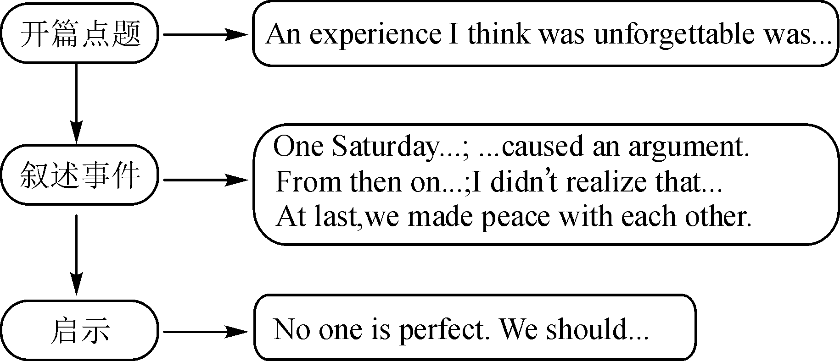

◆◆范文欣赏

**An Unforgettable Experience**

An experience I think was unforgettable was **arguing with** my best friend Li Hua.

One Saturday last term，Li Hua and I were studying together at his home. We had different opinions about a math problem. Such a little thing caused an argument between us. **From then on**，we didn't talk to each other. I knew that **it was my fault**，but I **refused to admit** it because I didn't want to **lose face.** I didn't realize that we wouldn't see each other anymore until I heard that Li Hua would move to another city with his parents. **Two days before he left with his family**，I said sorry to Li Hua. At last，we **made peace with each other. This made me feel a sense of relief.**

**No one is perfect.** Everyone makes mistakes. We shouldn't **be afraid of** making mistakes. When we realize our mistakes，we should correct them **at once.**

单元写作练笔

假如你是任慧，你校校报Speak Out栏目正面向全校征集关于“Something that made you happy or sad”的稿件，请你根据以下要点提示写一篇短文投稿。

要点提示：

1．What's the thing?

2．When，where and how did it happen?

3．How did it make you feel?

4．What did you learn from the thing?

要求：不少于100词，可适当发挥。

______________________________________________________________________________________________________________________________________________________________

**【课时小结】**

重点词组

1. lose the competition输了竞赛

2. get good grades on an exam在考试中取得好成绩

3. get into a fight with your best friend与你的好朋友发生争吵

4. speak in front of many people在众人面前讲话

重点句式

1. What did you learn from the experience?

2. Fame is not very important. It can make me nervous if too many people follow me around.

**【达标检测】**

**Ⅰ. 根据汉语意思完成英语句子，每空一词。**

1. 这支球队没让球迷失望。

The team didn't _________ _________ _________.

2. 地震后，这所房子仍然是安全的。

After the earthquake, the house _________ _________.

3. 贝姬很难过，她认为这是她人生中最糟糕的一天。

Becky is very sad. She thinks it is _________ _________ _________ _________ _________ _________.

4. 狗有敏锐的嗅觉，经常被警察用来搜寻一些东西。

Dogs have a sharp sense of smell and are often used to _________ _________ something by the police.

5. 你有没有犯错误没关系。从错误中学习，你就会进步。

It doesn't matter if you have made mistakes. _________ _________ _________ _________ and you'll make progress.

**Ⅱ. 根据短文内容及所给首字母提示，补全文中所缺单词，使短文完整、通顺。**

Hi, my name is Matt. When I was small, I lived with my aunt and her two sons Kevin and Carl. So I formed a close f        (1) with Kevin and Carl. Of course, I knew a lot about the two boys.

Kevin's face was as p        (2) as chalk when he was small. My aunt was always worried about him. She often took him to the hospital. She asked the doctor to e        (3) Kevin. But every time the doctor said Kevin was healthy.

Carl was too heavy when he was small. Every day he was busy trying to lose his w      (4). Carl did a lot but he was still too heavy. That d        (5) Carl. Carl also let my aunt down. The main reason was that Carl was lazy r       (6) than heavy.

       To be exact, my aunt was satisfied (满意的) with neither Kevin n        (7) Carl, because they were not good at their schoolwork. B        (8) they often fought with other students. Well, sometimes the two boys drove my aunt crazy.

**【自我评价】**

1. 本课我学会了什么？

________________________________________________________

2. 通过本课的学习，我还有哪些疑问？

________________________________________________________

**参考答案**

**【课前预习】**

一、1. 越……越…… 2. make me sleepy 3. 等她 4. friendship

5. 开始于 6. let … down 7. 开除 8. give up

9. 对某人严厉 10. pull together 11. 对……意见一致

12. would rather

二、1. weight 2. pull 3. agreement 4. teammates 5. kick

探究一

1. 1) win/lose the competition

2) get good grades on an exam

3) get into a fight with your best friend

4) speak in front of many people

2. 1) making noise outside

2) kicked him off

3) too hard on

4) saying a word

探究二 A

探究三

1. argue with sb.
2. make sb. happy
3. let sb. down
4. would rather do sth. than do sth.
5. learn from one's mistakes
6. different opinions
7. made me feel
8. be afraid of making mistakes

Something that made me happy was winning the piano competition. **It was held** on September 20th in City Music Hall. On that day，I saw many people there. I was so nervous. I was worried I would **make mistakes during my performance.** Then I remembered what my father told me—always **believe in yourself;** you are the best. His words made me feel much better. When it was **my turn to play**，I walked up to the piano with confidence and performed well. You **wouldn't believe how much** I wanted to know the result. When I learned I won first prize，I hugged my parents **in excitement.**

This experience taught me that it is very important to **have confidence in**

**yourself.**

**【达标检测】**

Ⅰ. 1. disappoint the fans  2. remained safe  3. the worst day of her life

4. search for  5. Learn from your mistakes

Ⅱ. 1. friendship  2. pale  3. examine  4. weight

5. disappointed  6. rather  7. nor  8. Besides